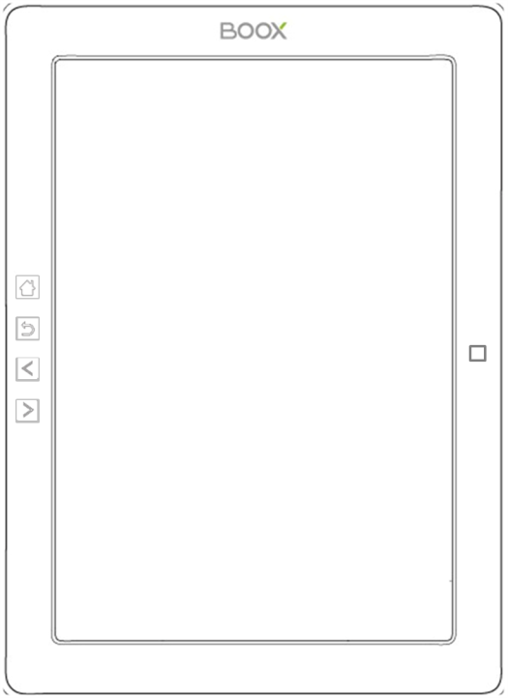

**BOOX M96 SMART READING SERIES**

**User Manual V1.6**

**Table of Contents**

[**1. About ONYX 3**](#_Toc393199228)

[**2. Standard Accessories 4**](#_Toc393199229)

[**3. Safety Guide 5**](#_Toc393199230)

[**4. Product Views 7**](#_Toc393199231)

[**5. Interface Introduction 11**](#_Toc393199232)

[**6. FAQ 45**](#_Toc393199248)

[**7. Warranty 47**](#_Toc393199256)

[**8. Specifications 50**](#_Toc393199260)

[**9. Declaration 52**](#_Toc393199261)

# About ONYX

BOOX is presented by Onyx International, which has a group of professionals who dedicate themselves in designing state-of-the-art reading terminal. The beauty of the BOOX is embodied in both its simplicity and its power. As we are going to show you, BOOX is an open and flexible platform for both consumers and content providers.

BOOX is powered by a 16-level grayscale e-ink screen that looks and feels like paper. Passive lighting and diffuse surface relax your eyes and reduce eye strain. By the hand-writing system, you can take notes while reading and sketch up ideas that happen to emerge. BOOX takes full advantage of new-generation e-ink screens: extremely low power consumption without reflection and backlight. Each full charge can sustain a few weeks' reading. By reducing paper consumption while providing a realistic paper-like reading experience, digital content helps to protect the environment without sacrificing convenience or life style.

For content partners, we also provide support for custom formats and digital rights management solutions. All of our viewers have standard features such as layout management, font adjustment, full text search, zooming, and page flow.

For a next-generation information device, connectivity is essential. The user can connect to the Internet by build-in Wi-Fi, 3G module or other add-on modules to download new content or surf the web. Customized for the e-ink screen, WebKit, the same software engine as some powerful desktop browsers such as Safari and Chrome, is the web browser of BOOX.

**BOOX gives you a new reading experience.**

# Standard Accessories

**Included in the Box：**

1. BOOX M96 Reader x1

2. Stylus Pen x1

3. USB Cable x1

4. Quick Start Guide x1

5. Warranty Sheet x1

**Optional Accessories（Purchased separately）**

1. Adapter

2. Stereo headphone

3. Protective Cover

# Safety Guide

Please read the Safety Guide carefully before you start to use the device. Contact your BOOX retailer if you have any technical problem; or you can dial our official service line at 4008-860-830 .

**E:\BOOX说明书\E43系列\E43截图\Icon\screen.jpgScreen protection**

The device is equipped with Eink screen, which is very fragile. Please have no shocking, squeezing, pressing against the screen, or dropping the device from higher place. If the screen is already broken, stop using it and contact the professional or other qualified staff to replace the screen for you. Please don’t dismantle the device without our permission;

**E:\BOOX说明书\E43系列\E43截图\Icon\acce.jpgStandard accessories**

Only the battery, adapter, and other accessories meeting our standard safety rules can be used for the device. For details, please refer to Product Specification. We will not be responsible for any damage caused by incompatible accessories;

**E:\BOOX说明书\E43系列\E43截图\Icon\liquid.jpgStay away from liquids**

The device is not waterproof. Don’t expose the device to humid environment or use it in the rain. Please keep it away from any corrosive liquids;

**Don’t dismantle the device**



Please don’t dismantle the device in case of any damage ;

**E:\BOOX说明书\E43系列\E43截图\Icon\temp.jpgUsing environment**

The using environment of the device is 0°C-50°C ;

# Product Views

**Front View**

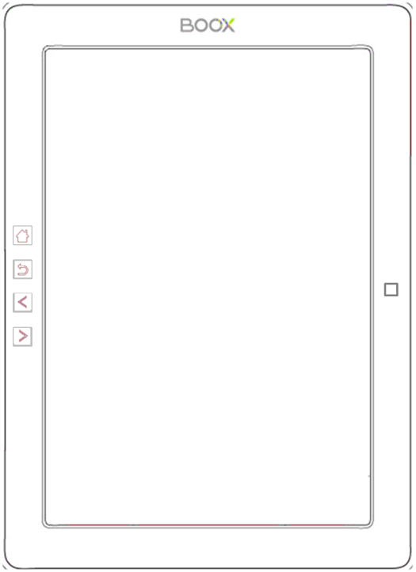

Menu

Five-way Joystick

Back

Prev

Next

**Back View**

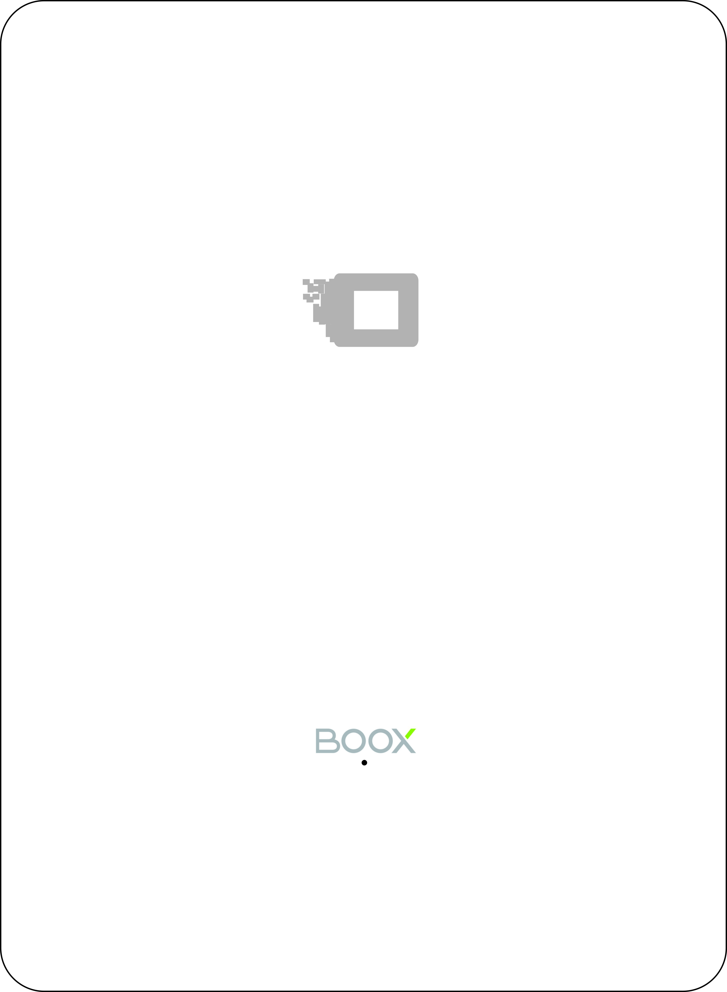

Speaker

**Bottom View**

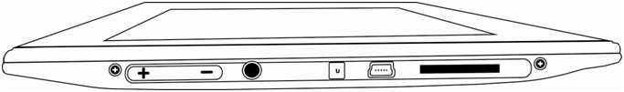

Volume

Audio Jack

Power

Mini USB Slot

SD Card Slot

**Button Function**

|  |  |
| --- | --- |
| **Power/**  **Standby Button** | * Press the power button to turn on the device * Press the power button and hold for 2 seconds to turn off the device. Or select “Power off”in the menu to turn off the device. * Press the power button and release quickly to let the device go standby or wake up. * Press the power button for 8-10 seconds to reset your device , then press it quickly to restart . |
| **Menu Button** | * Press the menu button to pop up the menu. * Same as the function that tapping the menu icon on screen |
| **Back Button** | * Exit the current apps; * Exit the current view or dialog; * Go back to previous directory |
| **Next Button** | * Turn to next page when reading or viewing files; |
| **Prev Button** | * Turn to previous page when reading or viewing files; |
| **Five-way Joystick** | * Users can swith from one icon into another on current screen by moving joystick. For example, press RIGHT button to swith from “library”into “SD”card. * While reading PDF or Epub, users can move the joystick leftward or rightward to swith from previous view into next view and move upward or downward to zoom in/out the fonts. * While browsing webpage, users can move the joystick leftward or rightward to come back to previous webpage or go into next webpage. * Press the joystick with power to select a icon, open a document or confirm your option. |
| **Volume control button** | * Press Vol+ to turn up the volume * Press Vol- to turn up the volume |
| **Audio Jack** | * Diameter of the audio jack is 3.5mm |
| **SD Card Slot** | * Insert SD card to read the content on SD card |
| **USB Slot** | * Connect the device with PC to transfer data or recharge. |

# 5. Interface Introduction

## 5.1 Main Interface

The main interface contains “Status Bar”, “Now Reading”, “Recently Added”and “Function Area”.

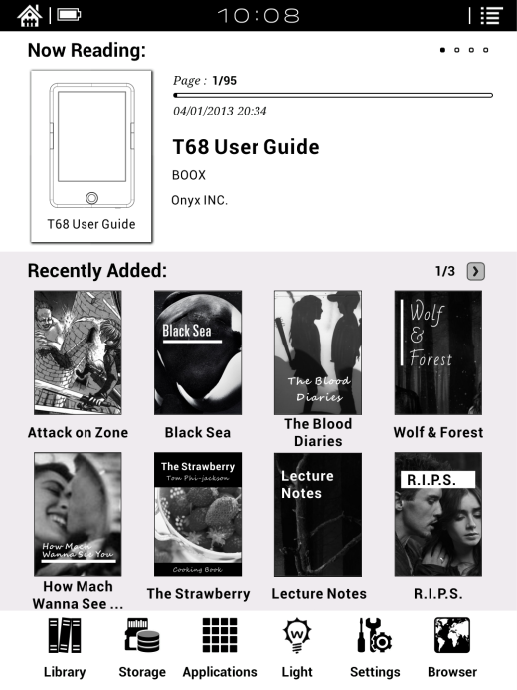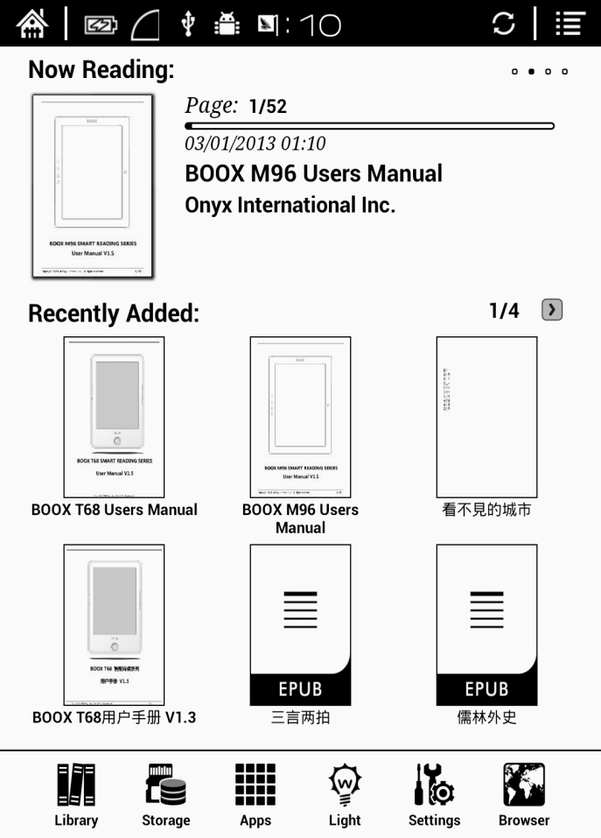

**Status Bar**

**Now Reading**

**Recently Added**

**Function Area**

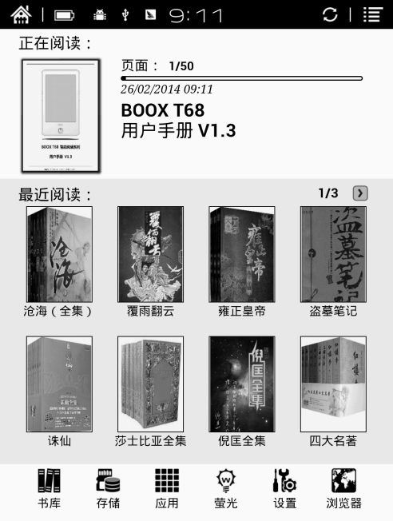**Status Bar**

This section displays the current state of the device, including: home icon, battery usage, notification, time, A2 mode on/off, Setting etc；

* **A2 mode refreshment**

Two-grey level refreshment mode is good for fast refreshment of text page. It enables fast pageturn, no screen flashing and less ghost background. When A2 mode is on, reading articles with images, graphics, texts mixed are not suggested because of blur image would occur.

When A2 is on：

When A2 is off：

**Now Reading**

The information of recently read books is displayed in this section, including book cover, book title, author, page number, last read time, reading progress etc；

Tap book cover or book title can open the books and enter the page read recently.

Only those read books can display book covers while those unread books shall display BOOX cover by default；

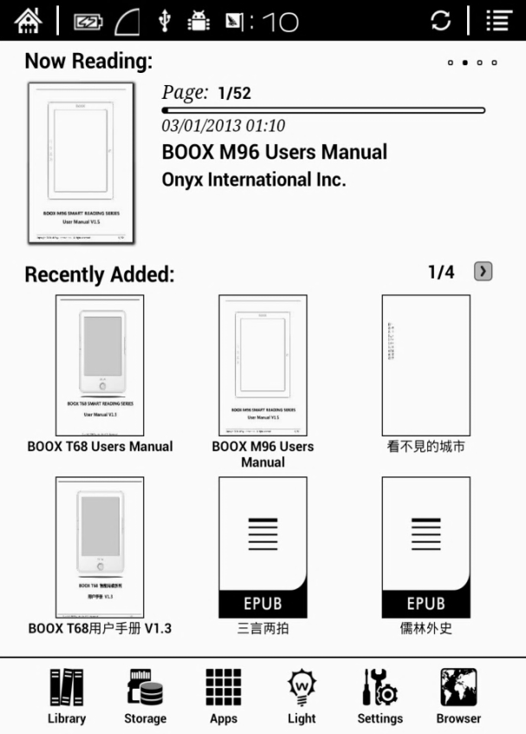

**Recently Read/Recently Added**



The newly added books will be listed here chronologically. Slide the screen or press the prev/next button to turn pages.

Users can switch into “Recently Added”through “system—user preferences—homepage options”, then it will display the book list added recently.

**Function Area**

This section displays some frequently used function icons, including Library, Storage, Apps, Setting, Browser.

* 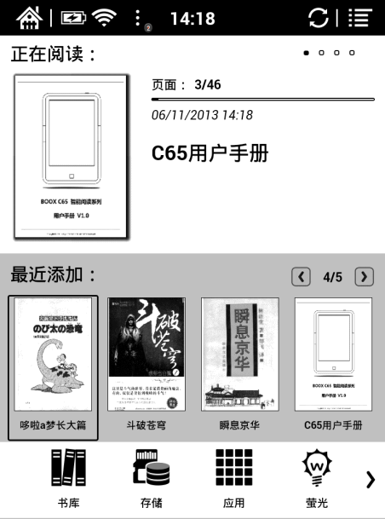 Library

All books supported by the device will be displayed here, including books from local storage and SD card.

Users can choose “Scanning”through Setting-System-User Preference to display all books supported by the device in directory “Books”including books from local storage and SD card.

* 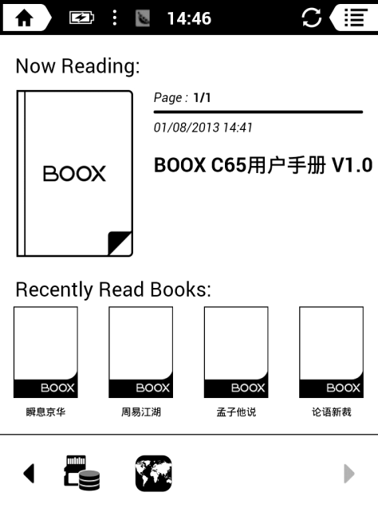 Storage

It displays all files both from local storage and SD card. Users can manage all files by customized folders to manage books, apps and other files.

* 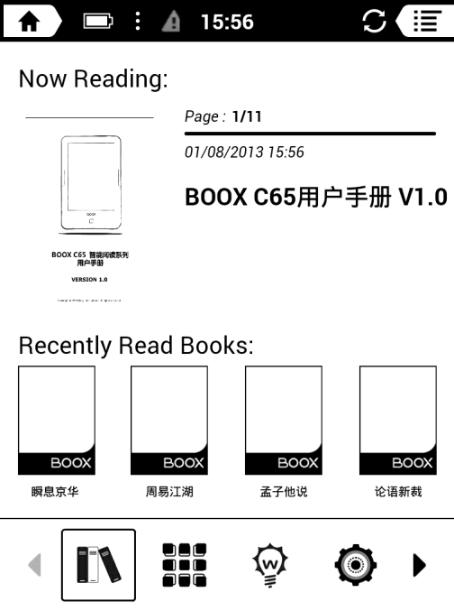 Apps

Going to Apps lists page, users can manage or uninstall the apps.

* C:\Users\Administrator\Desktop\mc_light.jpg Firefly light

Turn on/off the front light and adjust the brightness.

* C:\Users\Administrator\Desktop\Settings.png Setting

Going to setting interface, users can manage the settings for all items.

* 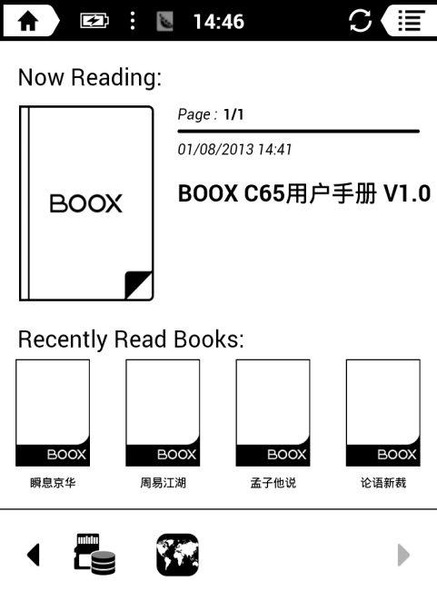 Browser

When WiFi is on, users can browse webs or download files from internet via Browser.

## 5.2 Notification Interface

Tap battery usage site on the right of the Status Bar to pop up Notification board; Press Back button or tap Home icon can exit.

Notification page contains: WiFi setting, date, volume control, setting, and other new msg notice etc;

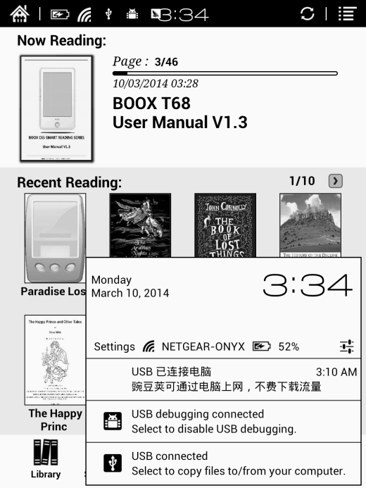

## 5.3 Reading Interface

Tap any book cover to go into reading interface. Only book content and page number are displayed here. Page number area includes page number, prev/next and current time.

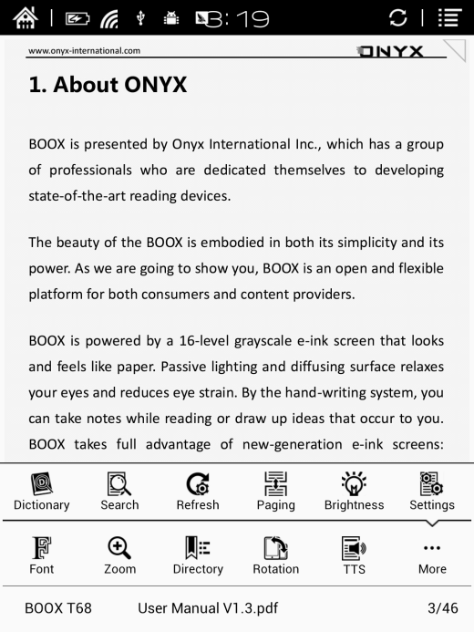

Tap the middle area of the screen or menu button to pop up reading menu and status bar;

Reading menu contains: fonts, zoom, directory, rotation, TTS, dictionary, search, refreshment, pagination view, setting etc ;

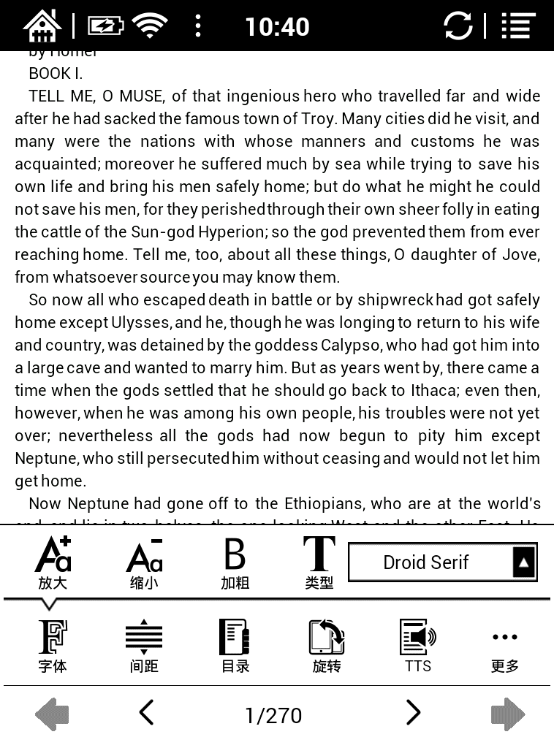 Font

Fonts can be adjustable (reflow mode is supported): font size, bold type, font change(only some formats supported), spacing(only some formats supported) etc;

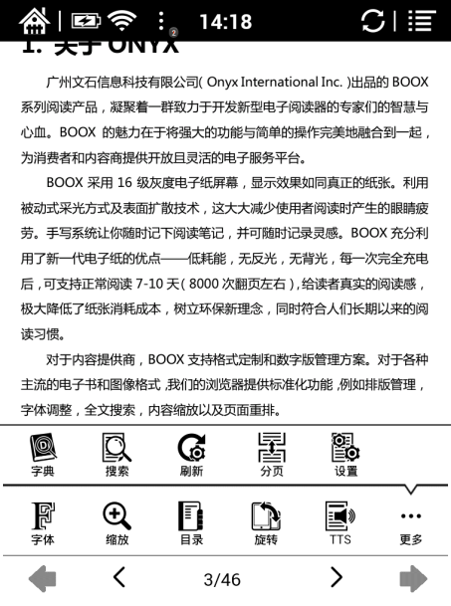Zoom

User can zoom in/out the page freely; Other zoom shortcuts are available: To width, To page, Crop, Selection to zoom; Reflow mode is not supported.

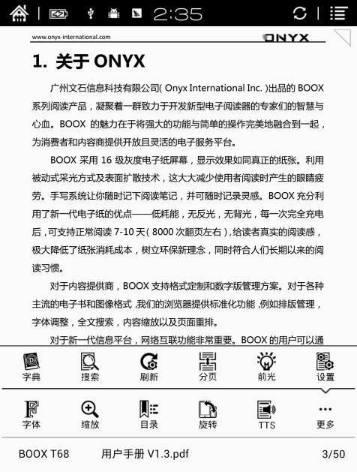Directory

TOC, Bookmark, Annotation can be checked here;

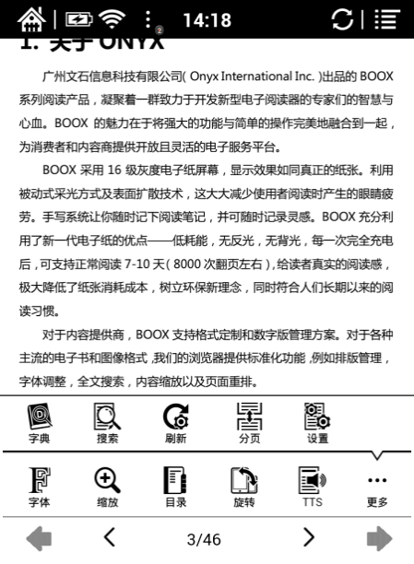 Rotation

Users can select the direction of the screen display;

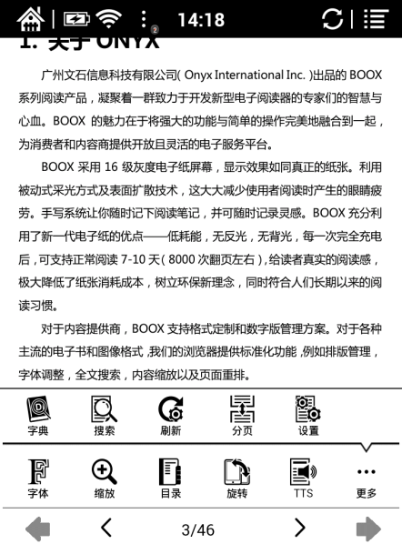 TTS

TTS is available for part of the documents.

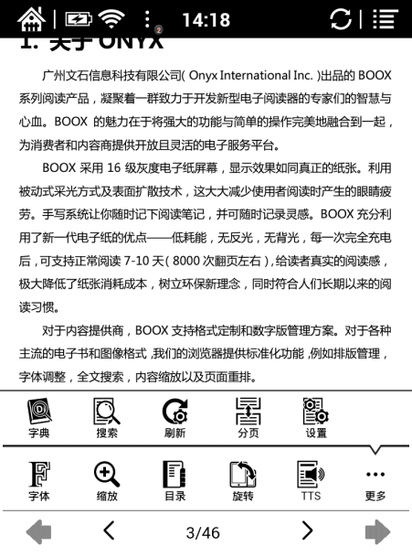Dictionary

Long press the content can pitch up words to pop up the dictionary. Stardict can be supported. Users can download Stardict dictionary and put it into folder“dictionary” on SD card, then the dictionary can be used when reading;

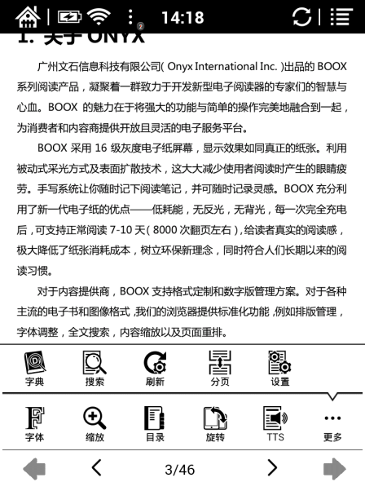Search

User can search the targeting texts;

Long press the input box can change input method;

Refreshment

Users can select screen refreshment rate by their preference, including full refreshment, 3/5/7/9 pages refreshment and never full refreshment. Every 7 pages to refresh is system default;

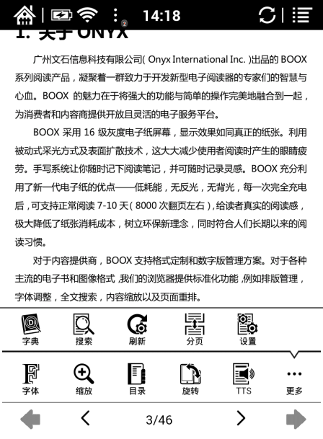Setting

Page margin, footer, time, navigation and dictionary for current content can be set.

## 5.4 Browser Interface

When WiFi is on, please tap Browser icon or choose in the apps management to start browsing online;

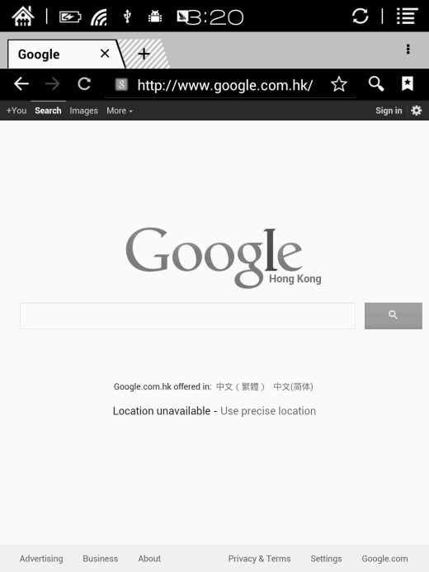

At browsing page, tap text box can pop up virtue keyboards;

Press the space key to switch English and Chinese mode. More input methods can be installed by users and switched through the input method options on the keyboard;

## 5.5 Library

The library can only display supported-format books; The books will be displayed by thumbnail view chronologically; There is no files browsing mode;

Users can change the display mode through the icon on top right corner( including breviary, listing mode, particular list) and users also can search books;

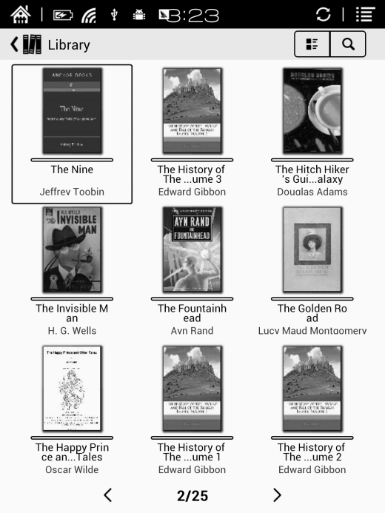

Tap the menu key on the top right to pop up library menu, including open pattern, sequencing, attribute, filter, skipping, rename, delete, history, note etc;

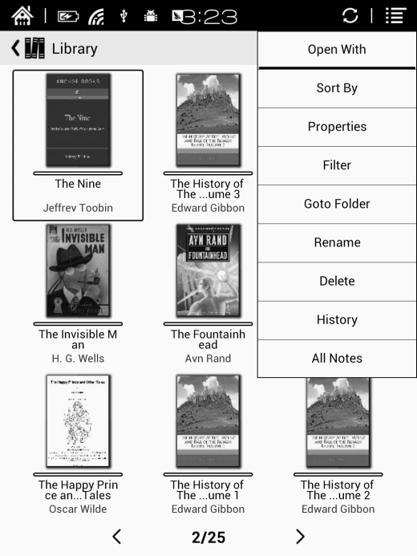

**Sort by**

Users can sequence the book by names, types, sizes, created time;

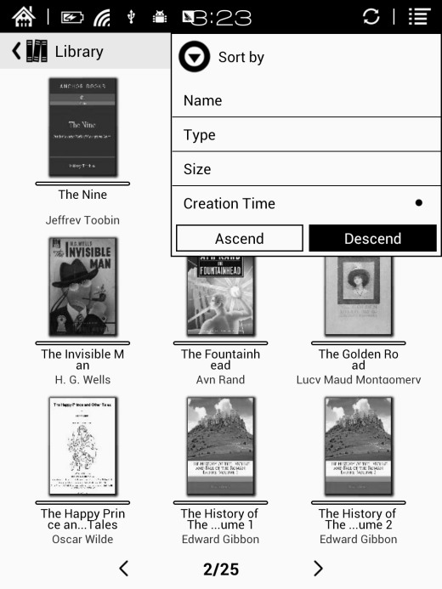

**Filter**

The books in the library can be filtered in reading mode, including all, unread，now reading, read，label etc;

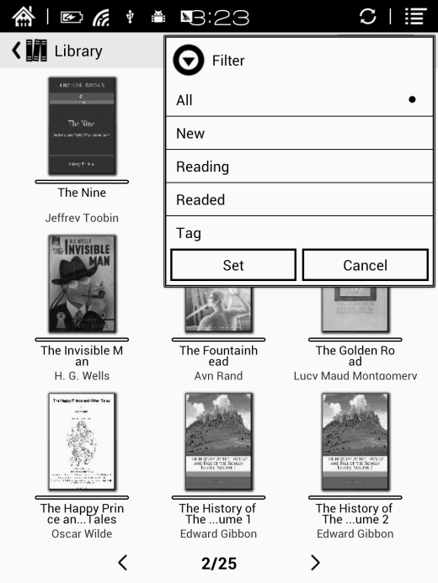

**History**

Users can find all reading history record of books that have been read, including reading progress, time, open times, total reading time etc;；

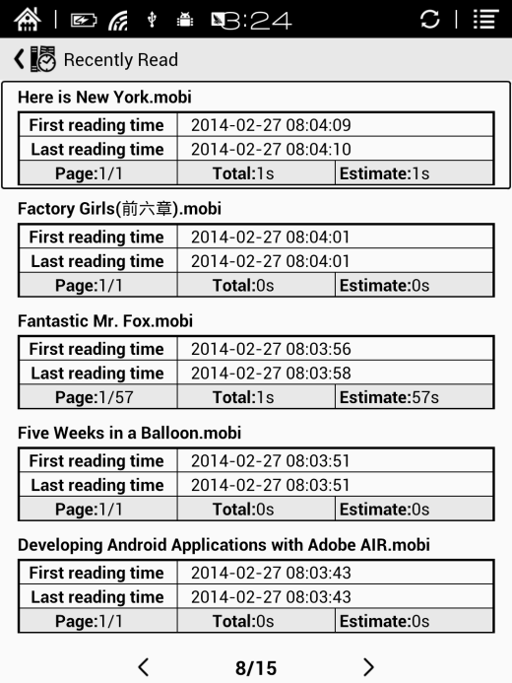

**All Notes**

Users can extract all the notes, highlights, annotations and other books record list, which can be referred directly without open the books;

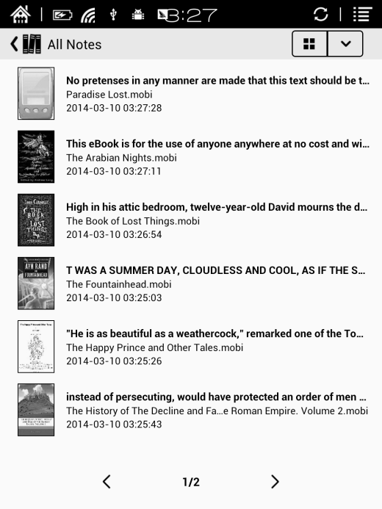

## 5.6 Storage

## Storage displays all files from both local storage and SD cards and manage in file mode. Files will be displayed in alphabetical order by default. Users can change the listing mode by themselves;

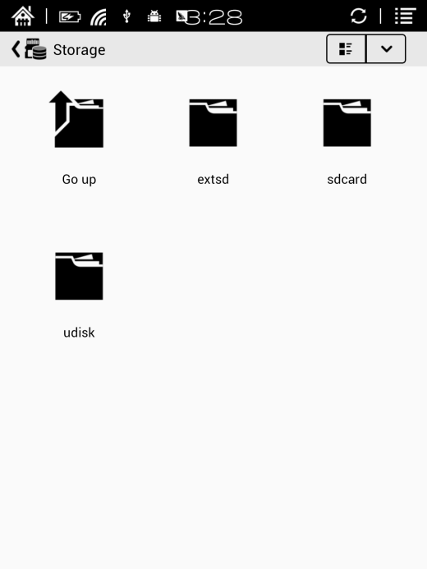

## 5.7 Apps

Here it will display all installed apps in alphabetical order. Users can change the listing mode by themselves;

Long press on each app can popup menu to manage or delete the Apps setting. Applications that come with the system can not be deleted by users;

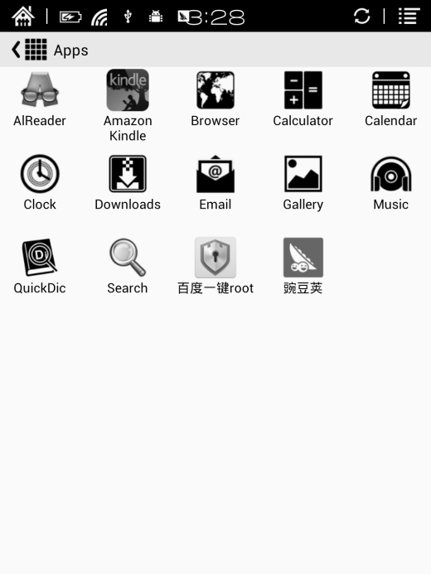

## 5.8 Light

Users can turn on/off the front light and adjust the brightness;

Users also can long press the OK button to turn on/off the front light quickly;

(this function is only available for some versions, please see the specifications for details.)

，

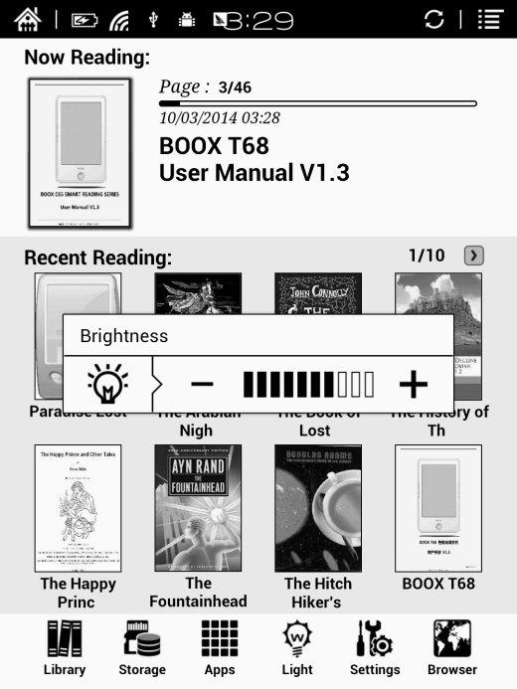

## 5.9 Settings

Users can set up general settings for the device, including System, Language, Extension, Networks and About;

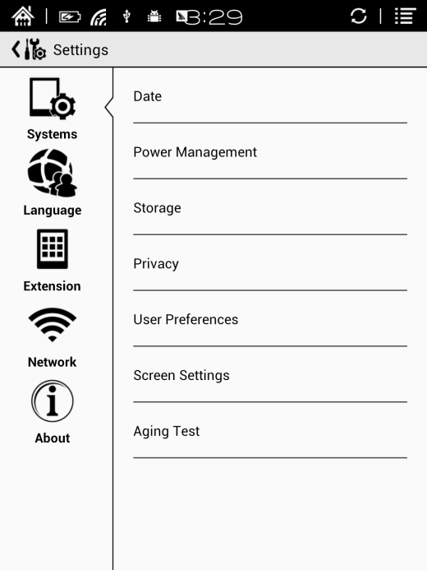

Users can tap the top right corner of the status bar to popup notification bar and choose “settings”to enter settings interface;

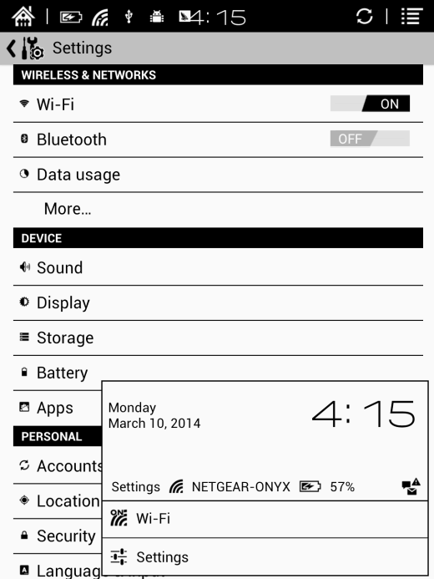

### 5.9.1 System

Users can set date, display option, storage, privacy, startup options of the device;

* **Date**

Users can select auto setting or manual setting to set the time. Auto setting will set the time automatically which matches the time online. when the device is connected with wireless internet；Manual setting needs users to set date, time zone and time on their own.

Users can set 12-hour time or 24-hour time and date display on their preferred way;

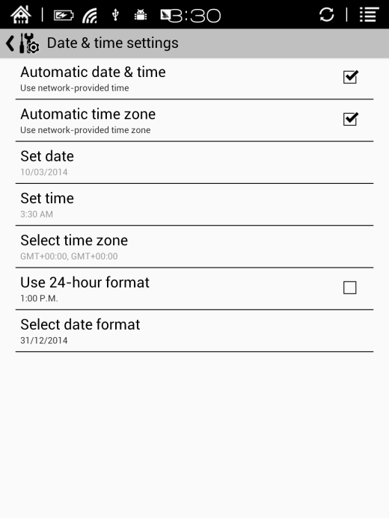

* **Display**

Users can set standby time here. It is 3 minutes by default;

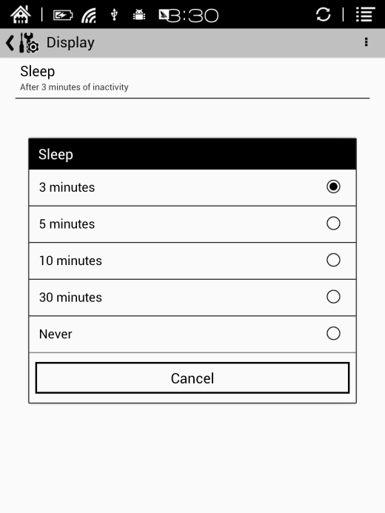

* **Storage**

Here it displays the total storage of device, including the usage of local storage, SD card, built-in FLASH storage etc;

**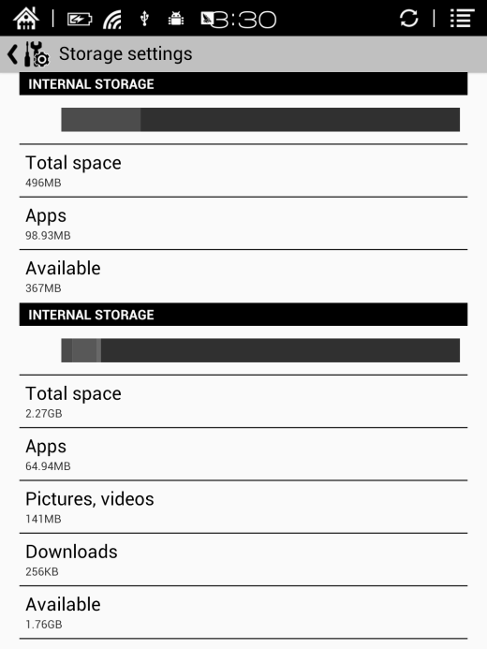**

* **Privacy**

This contains settings of data backup, data recovery and factory resetting etc;

Factory resetting will erase all user data. Please back up all user data before performing factory resetting;

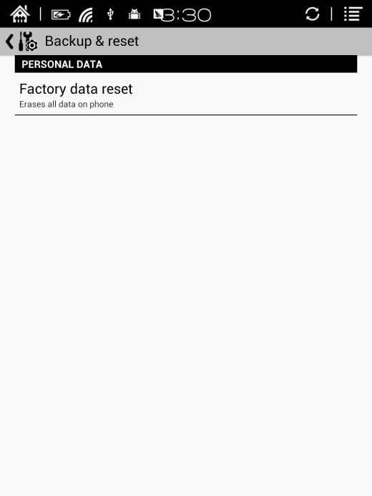

* **User preference**

Users can choose whether to open the last read book when starting the device; It will go directly to the main interface by default;

Users can choose whether to scan the book cover or not;

Users can select the path to scan books automatically;

Users can choose to display “recently read books or recently added books” at the main interface; It will be recently added books by default;

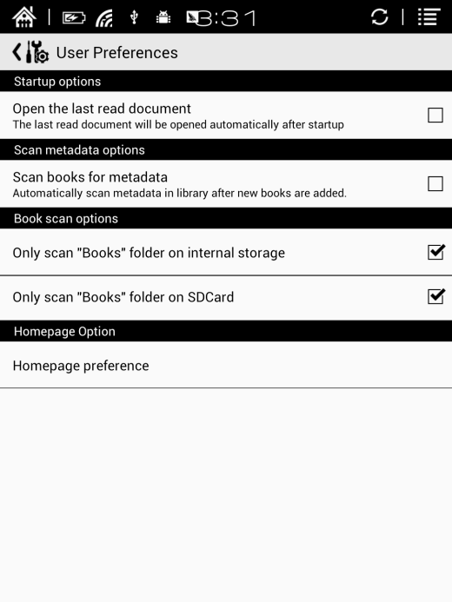

### 5.9.2 Language

Users can set system language, default fonts, TTS reading, dictionary on this page;

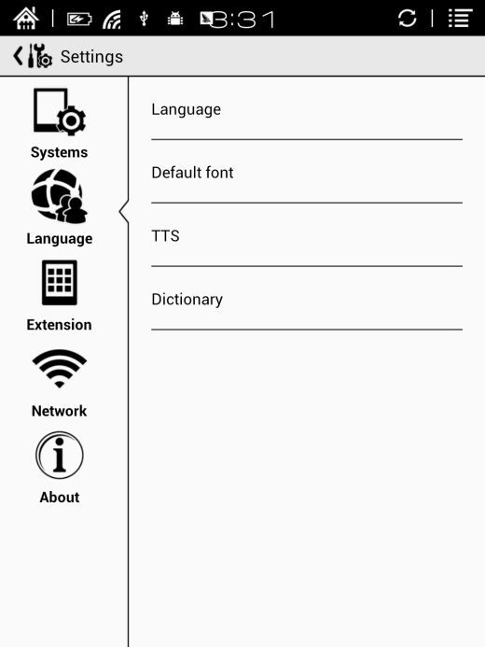

* **Language Settings**

Users can set languages of the system and virtue keyboard. The system has Android keyboard by default. Users can install third-party apps for more input methods and select in keyboard setting;

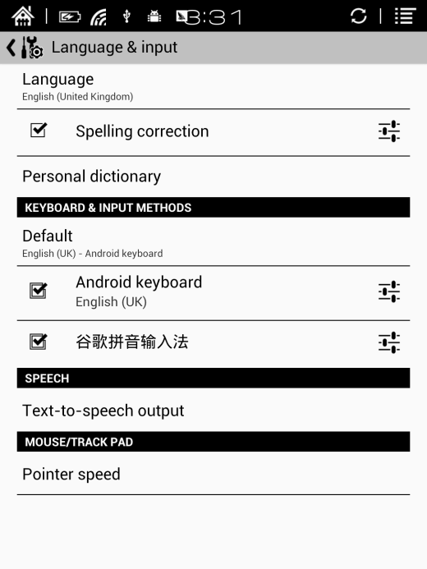

* **Default front**

Users can set the system fonts on this page, but reading fonts can be only set on reading page;

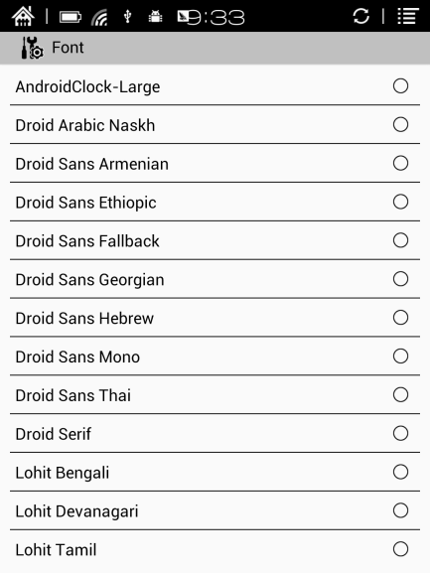

* **TTS Setting**

Users can set reading voice, speed and language by TTS (text-to-speech) setting;

Users can install third-party TTS apps and set that as first choice.

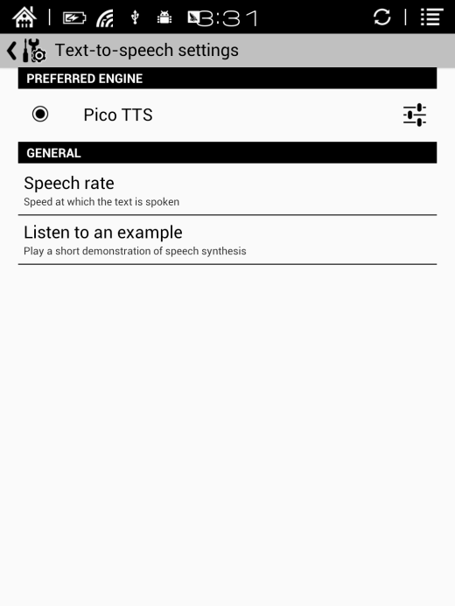

* **Dictionary**

User can select the installed dictionary apps here;

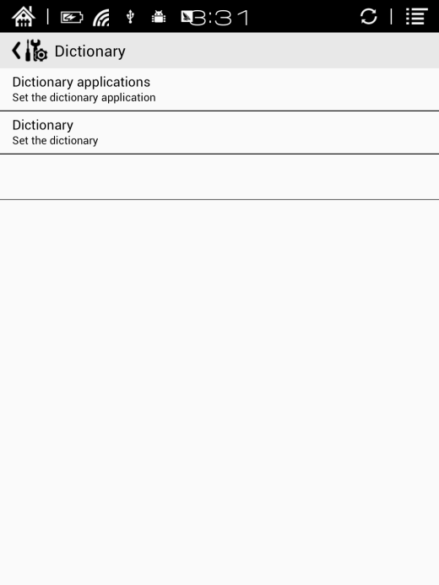

### 5.9.3 Extension

This contains Apps setting and DRM setting;

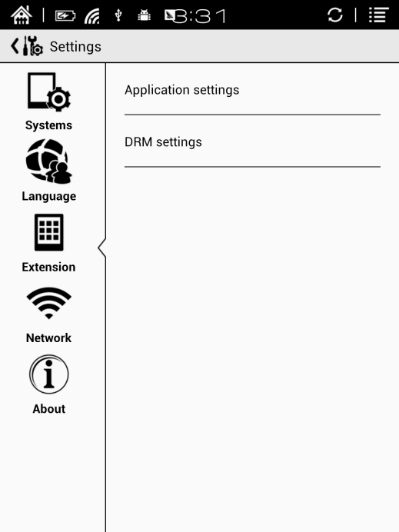

* **Apps setting**

Users can check Downloaded, SD card, Running apps and All apps here. Tapping any app can stop, unload, delete, and transfer it.

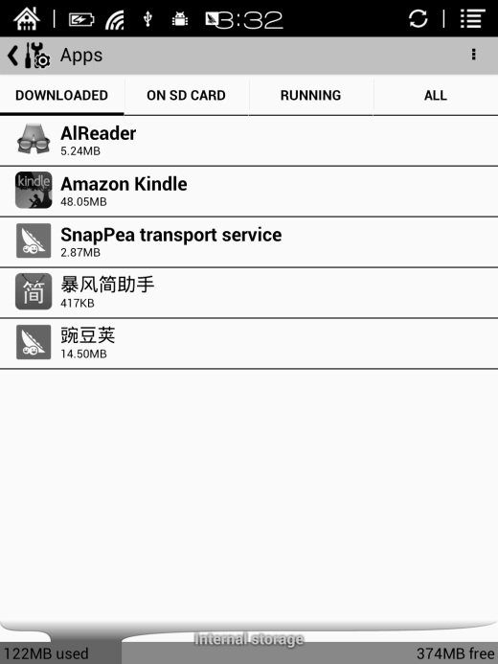

### 5.9.4 Networks

This is for WiFi setting. When WiFi is connected, users can browse webs and download books via internet on the device;

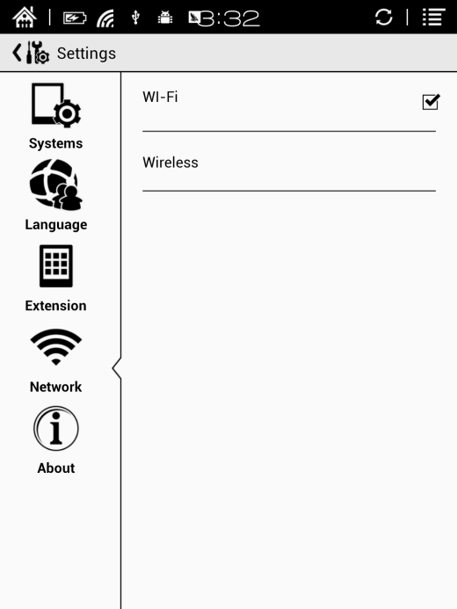

When“turn WiFi on”is selected, the device will search WiFi hotspot. When all available WLAN are listed, users can choose a network, input password to connect with internet. WiFi signal will be displayed at “Status bar” when WiFi is connected;

After WiFi is connected successfully at the first time, the device will save WiFi information automatically. Next time users can turn WiFi on and off by shortcuts on Notification board;

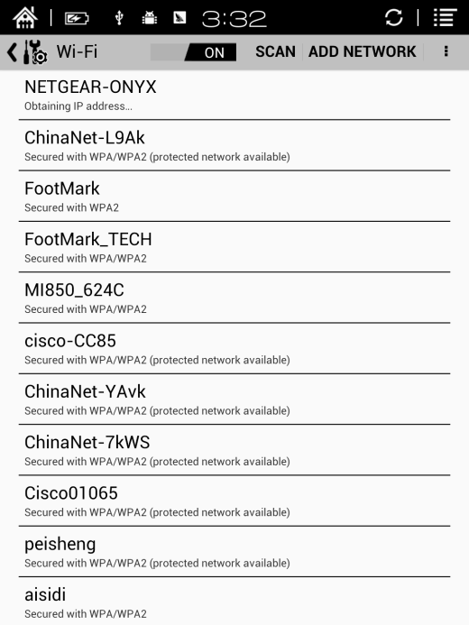

### 5.9.5 About

More information about the devices are listed here, including system update, notification, battery usage, legal info, model, firmware version etc;

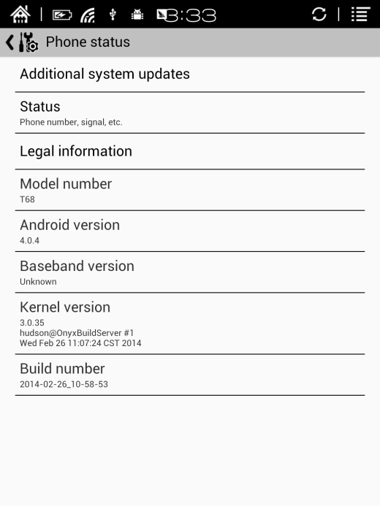

# 6. FAQ

## 6.1 How to turn the device on/off

When the device is off, press power button for 2-3 seconds to go into starting up interface and then into operating interface after the progess is finished.

When the device is on, press power button for 2-3 seconds to turn the device off;

When the device is on, pop up menu bar to select “Shutdown”;

## 6.2 How to charge

Recharge the device by connecting it with PC by USB cable;

Recharge the device by connecting with power adapter to alternating current plug seat.

Orange light is on when the device is charging. The light will be off after battery is fully charged;

Full single charge will take around 3 hours;

## 6.3 How to transfer data

Transfer data by connecting the device with PC via USB cable;

Transfer data by third-party sync apps between PC and the device via WiFi;

Download data or read online by browsing via WiFi;

Download data or read online by log-in of reading apps from third party via WiFi;

## 6.4 How to install dictionary

The device supports stardict dictionary;

Users can download the language package of stardict, copy it to folder“dictionary”on SD card. Dictionary is available to use after that when users are reading;

## 6.5 How to add fonts

Users can download fonts online, then copy the fonts to the folder “/adobe/resources/fonts”on SD card;

Users can select the installed fonts when reading, but the fonts are only available for some book formats;

## 6.6 How to update

Download firmware update.zip and insert SD card into the device. Find the update.zip through"Setting-About-other system update"to update locally;

Users can update the firmware online via OTA (Setting—About—System update); When WIFI is on, users can search update.zip online to update the device directly.

## 6.7 How to protect the device

To use protective covers for the device and avoid crashing, shocking, pressing against the screen;

Put the screen side downwards when the device is not in use; Don’t put rigid stuff in-between of the screen and other flat surface;

Don’t pile up or store heavy stuff above the device;

Keep the device away from all types of liquids.

# 7. Warranty

## 7.1 Scope of Warranty

7.1.1 The device：One-year warranty；

7.1.2 If in 15 days from the date of purchase, any faults caused by quality problem of the product itself under normal operation and without overhaul, you can replace the same type of product or enjoy maintenance services for free；

7.1.3 If in one year from the date of purchase, any faults caused by quality problem of the product itself under normal operation and without overhaul, you can enjoy maintenance services for free；

7.1.4 If in three-years from the date of purchase, the product has any faults, you can get maintenance services with a fee；

7.1.5 Above warranty or maintenance are limited to the fault of electrical components, including the hardware mainboard and display, not including housing, brochures, package, headphones and other consumables and accessories.

## 7.2 Beyond the scope of warranty

The following conditions are not covered by the warranty, even if in the applicable time period, the warranty will no longer works for it, but still can enjoy the fee-based services.

7.2.1 Faulted device without ONYX BOOX brand；

7.2.2 Faulted device caused by dismantling and repairing without permission.

7.2.3 The serial number of the faulted device has been changed or lost.；

7.2.4 The device is damaged due to personal factors or not being used under specific environment. For example, use the device in the environment where too wet or too dry, in high temperature or with instable voltage or current, etc.；

7.2.5 The device is damaged by accident or improper use, including devices filled with warter, rupture， collision, unnormal pluging, pests, ect.

7.2.6 Due to natural consumption, including natural consumption, wear and aging of housing and accessories.

7.2.7 Damage caused by force majeure, such as fires , floods , earthquakes and other natural disasters

7.2.8 The device is faulted by operating the software beyond the range that SDK permitted.

7.2.9 The device has been identified that it is not produced by ONYX.

## 7.3 Precautions for repair

7.3.1 Users need to contact our after-sales department to confirm whether it is in the scope of warranty, whether it is fault and the fault cause.

7.3.2 Users need to provide proof of purchase (invoice or receipt) , warranty card consistent with the original barcode. Fill out the repair request form (download from official website) and then send to our maintaining department together with the device.

7.3.3 Due to the special properties of the product screen, for non- screen maintenance equipments, please ensure that the screen is intact and reinforce the packing before send it to us. Please avoid damage in transportation. We do not receive a damaged screen products for free maintenance.

7.3.4 Please only send the device and the materials required above to us. Do not send the headphones, adapters and other accessories. If lost, our company is not liable for damages;

7.3.5 Please backup data before send it to repair. We are not liable for the data loss due to maintenance.

This provision only applies to mainland China. It is protected by the Chinese consumer protection law; If the same model is purchased in other regions, it cannot enjoy the above terms. Please consult related consumer protection law and dealers of the country where you purchase the device.

ONYX International Inc. reserves the right of final interpretation of this warranty.

# 8. Specifications

|  |  |
| --- | --- |
| **Processor** | 1G Hz |
| **RAM** | 512MB LPDDR |
| **OS** | Android 4.0 |
| **Storage** | Built-in 4G |
| **Screen** | E-ink display |
| **Screen Size** | 9.7 inch |
| **Resolution** | 1200x825 |
| **Touch** | Capacitive touch |
| **Front light** | Not support |
| **Wireless** | WIFI |
| **Battery** | 1700mAh |
| **USB** | USB2.0 |
| **Audio Jack** | 3.5mm |
| **ExtCard** | SD card (up to 32G) |
| **Size** | 241x178x11mm |
| **Weight** | ≤520g(including the battery) |
| **Operating temperature** | 0°C- 50°C |
| **Supported book formats** | PDF, EPUB , TXT, DJVU, HTML, FB2, DOC, MOBI, CHM, PDB |
| **Supported image formats** | PNG, JPG, GIF ,BMP |
| **Supported audio formats** | WAV , MP3 |
| **Apps** | APKS installation is supported |
| **Browser** | Support |
| **Language** | Multi-language supported |
| **File directory** | Support |
| **Dictionary** | Support |
| **TTS** | Support |
| **Refreshment mode** | A2 quickly refresh, partly refresh and fully refresh |
| **DRM** | Support |
| **Firmware update** | Locally update and OTA update are available |
| **Certification** | CE、Rohs |

# Declaration

Onyx International Inc. reserves the right to modify the content of the Quick Start Guide and User Manual without further notice.

For more information, please visit our website at

[www.onyx-international.com](http://www.onyx-international.com/)